LAB 2 ANDROID – ASYNCHRONOUS TASKS AND SENSORS

**Student** : Matthieu GEDEON

**Teacher** : Jean-François LALANDE

Table des matières

Authentication with an asynchronous task 3

Asynchronous tasks for a real remote service : Flickr 4

Github link to the project : <https://github.com/Fraisedesneiges/android-tp2>

# Authentication with an asynchronous task

This work is the project **part-one** in the **android-tp2** folder.

The goal of this part is to do a simple authentication by submitting credentials to the “HTTPBin” ([https://httpbin.org/basic-auth/bob/sympa)](https://httpbin.org/basic-auth/bob/sympa)%20) online service using a a Thread object.

**Exercise 3**: The readStream method must be user implemented. By searching on StackOverflow, you can find several solutions that can be used as the body for this method. I choose one with a StringBuilder and a BufferedReader for better efficiency.

**Exercise 4**: You can see the errors on the Logcat, the Build or the Run tabs on the bottom of the Android Studio IDE.

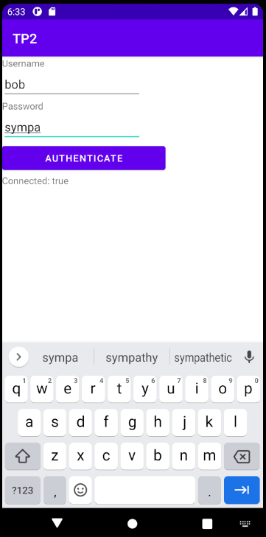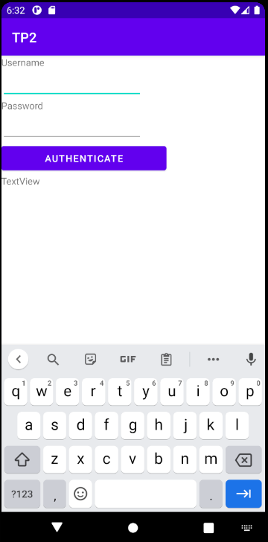

# Asynchronous tasks for a real remote service : Flickr